CSA05 – Database Management Systems - Practical Examinations Questions Paper
Time: 3 Hours SET -9 Max Marks: 100 (25 each)
Airline Reservation System

NAME : MONIKA.B
REG NO :192571002

Scenario
An airline operates flights and handles passenger bookings.
- Flights (flight_id, flight_number, origin, destination, total_seats, available_seats)
- Passengers (passenger_id, name, email, passport_no)
- Bookings (booking_id, flight_id, passenger_id, booking_date, seat_number)
- Cancellations (cancel_id, booking_id, cancel_date, refund_amount)

Questions
- SQL & Joins: Write a query to list all passengers traveling from 'New York' to 'London', showing passenger_name, flight_number, origin, destination, and booking_date.

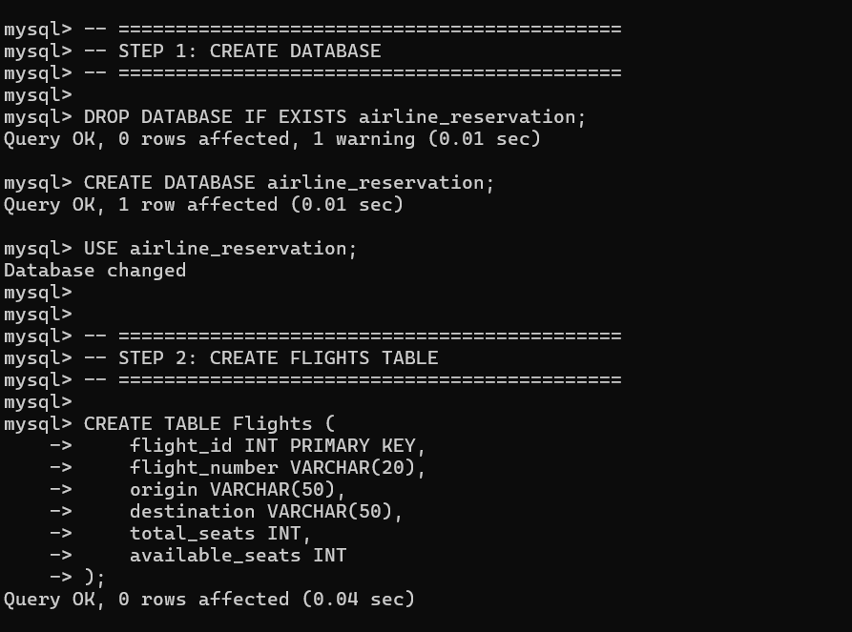

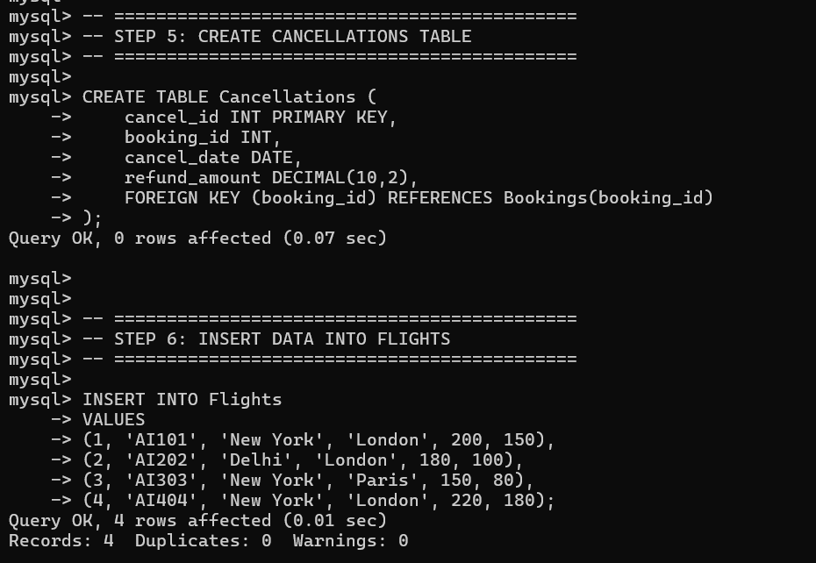

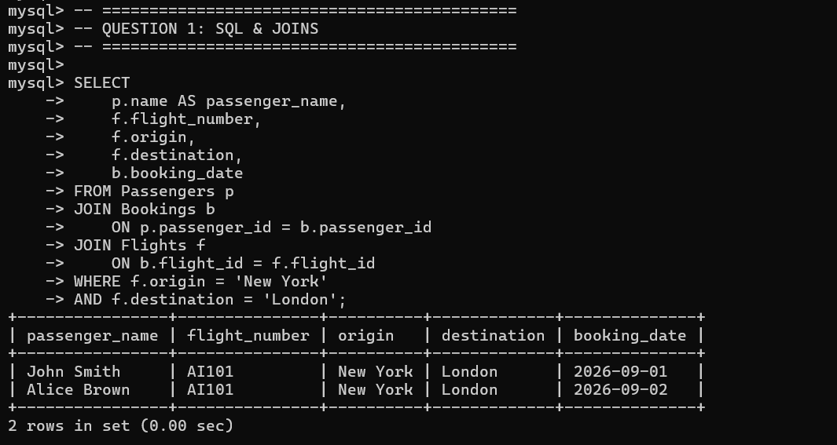

- Views: Create a view vw_flight_occupancy that displays flight_number, origin, destination, total seats, available seats, and occupancy percentage.
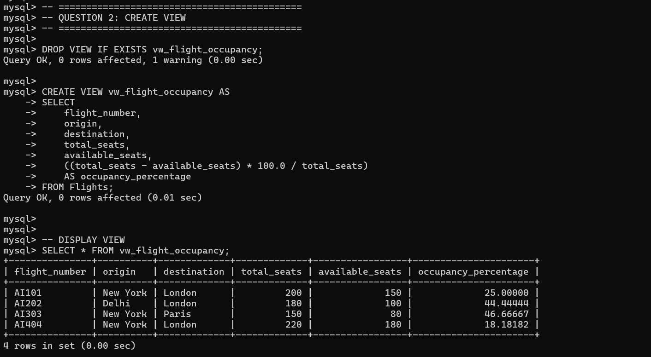

- User-Defined Function: Write a function fn_check_seat_availability that takes a flight_id as input and returns a boolean/string flag indicating whether seats are available (available_seats > 0).
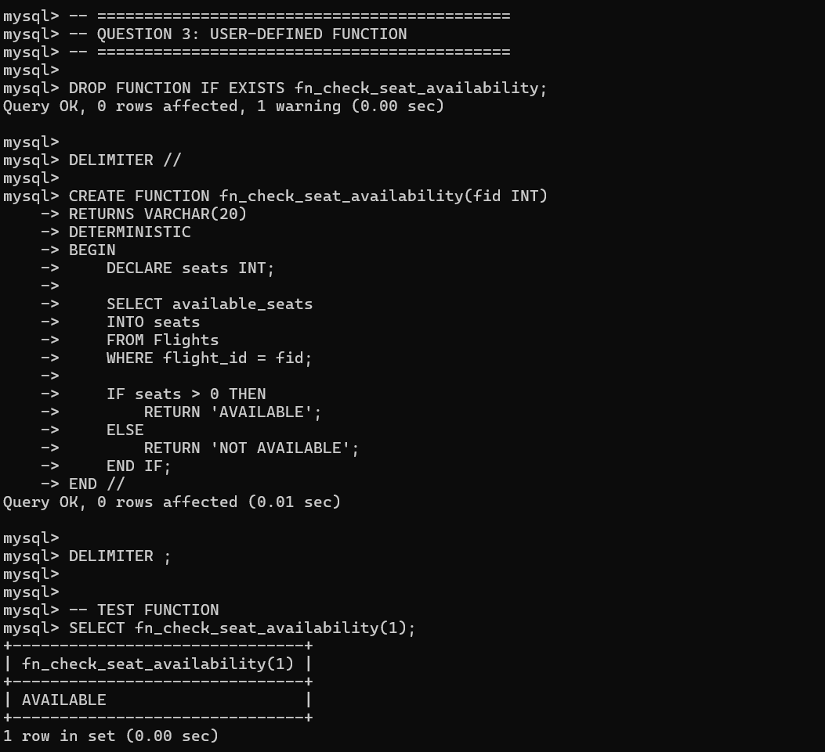

- Triggers: Write an AFTER INSERT trigger on the Bookings table that automatically decrements available_seats in the Flights table by 1 whenever a new booking is confirmed.
